

**MVP GENERATOR**

BTP Mid Term Evaluation Report

**Under the guidance of asst prof. Sushama Nagpal**

Akanshi Gupta *(216/CO/12)*

Chitrasoma Singh *(254/CO/12)*

Divjot Singh *(262/CO/12)*

**CONTENTS**

* Problem Statement
* Case Study
* Conclusion
* Introduction
* Advantages
* Architecture
* Database ERM
* API
* Generator
* Principles Followed
* Technologies Used
* Phases Of Development
* Phase 1 (App) Stages
* Phase 2 (Generator) Stages
* Current Status

**PROBLEM STATEMENT**

Modern applications have started converging to the point where they all are search engines around an entity. Same features such as a feed to view the entity items, a way to filter the feed, reviews around entities and a way to communicate with the entity, are implemented in all the applications. Existence of a pattern among these applications and services allows us to automate the process of development of the common features so as to help both software developer and the project lead to save time, use best practices, and prototype the application in a very short time.

**CASE STUDY**

We’ll present a list of famous applications and show the common pattern that exists around them.

1. **Zomato (Restaurant Finder)**

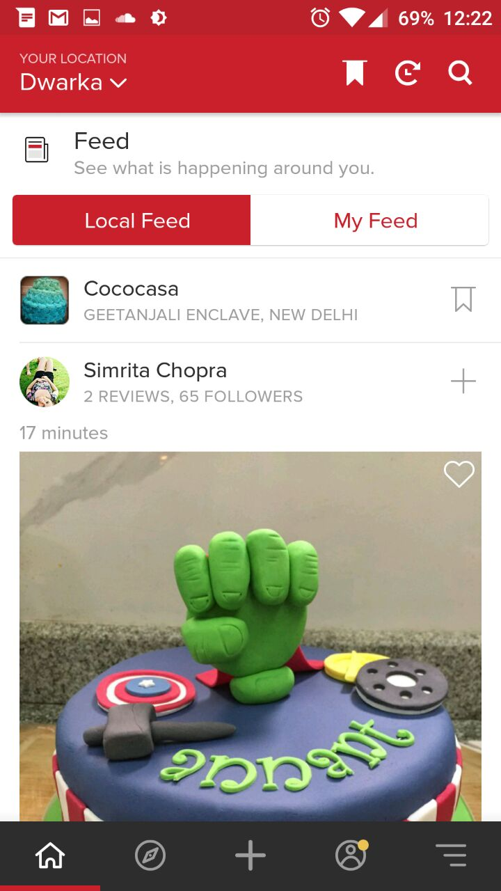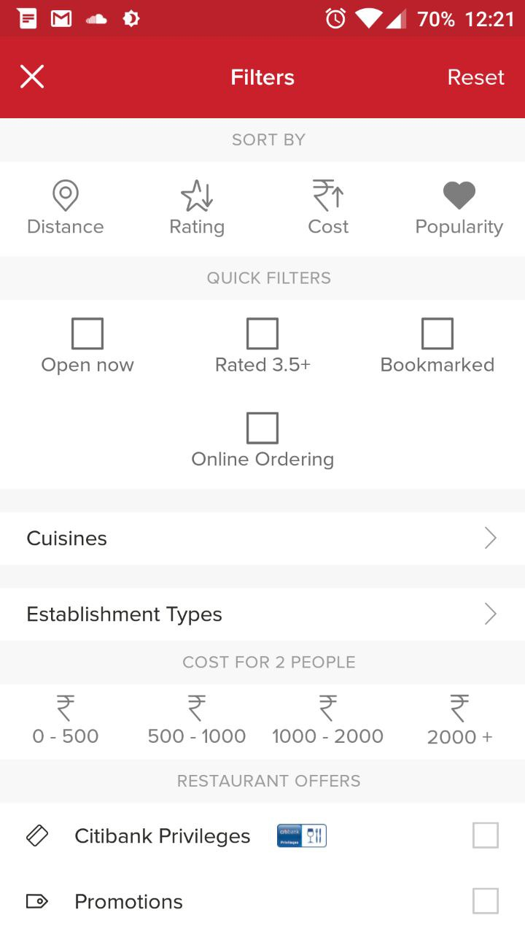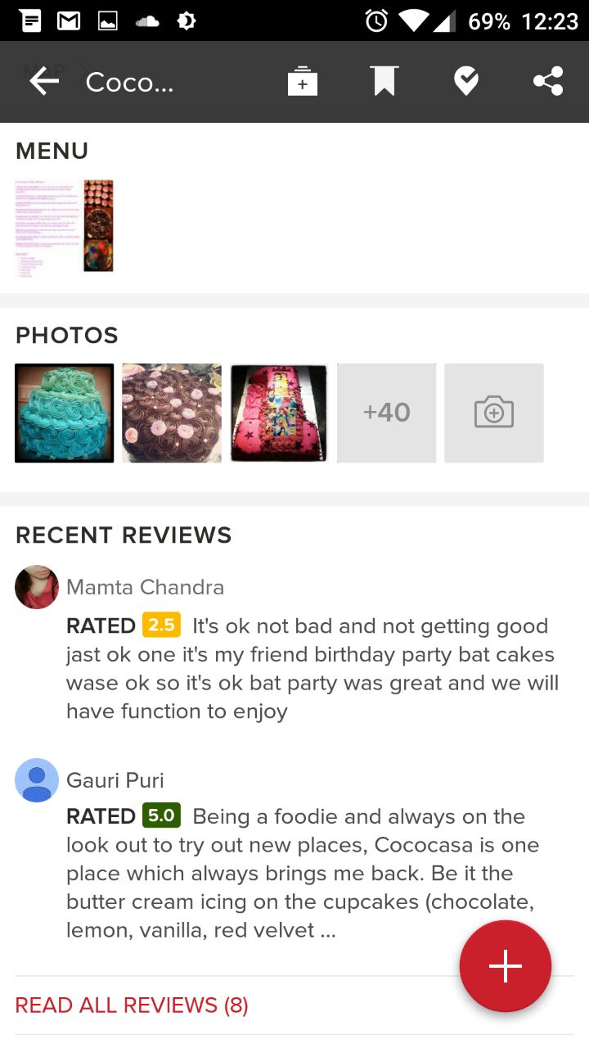

As you can see, the common features as we mentioned exist in Zomato. Note how the design too is followed by the following applications, even though they serve a very different purpose, i.e. the entity they search around is very different from restaurants.

1. **Practo (Doctor Finder)**

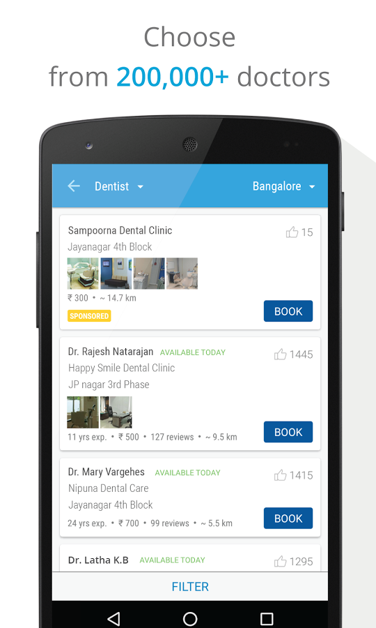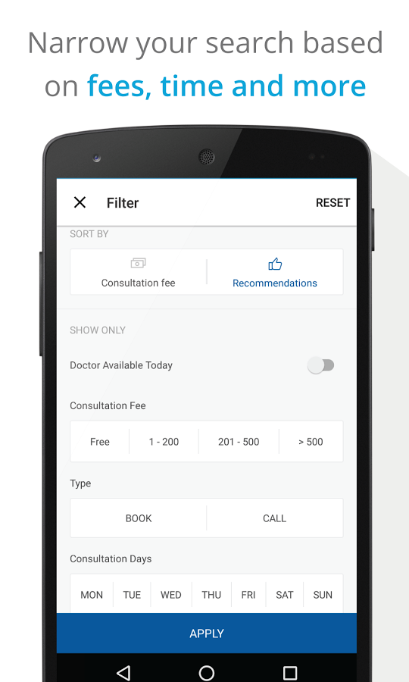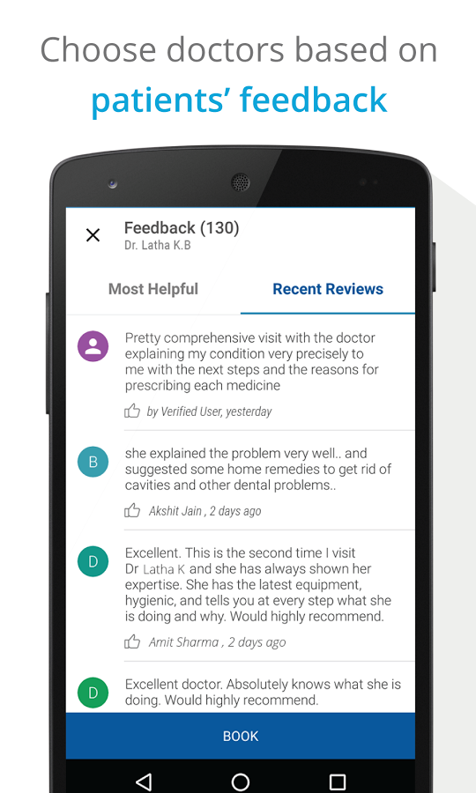

The next application is Practo. Note how the features as well as design is very similar to Zomato.

1. **Urbanclap (Service Worker Finder)**

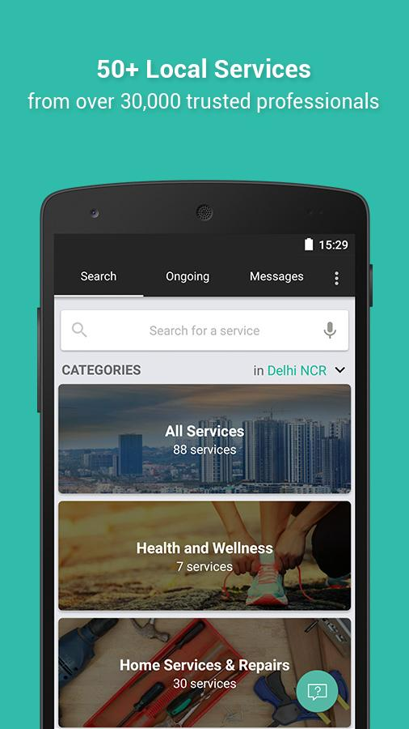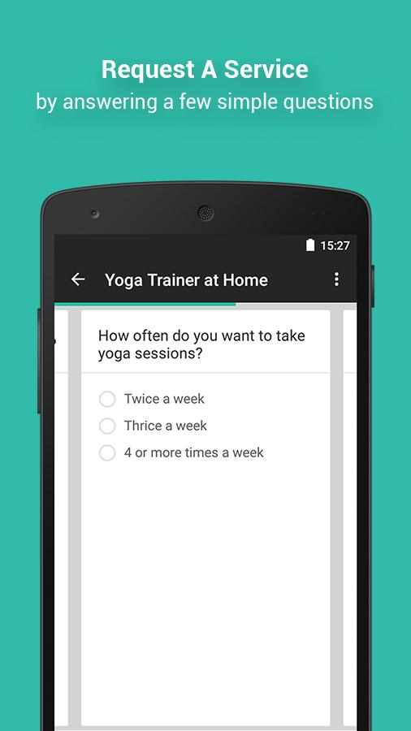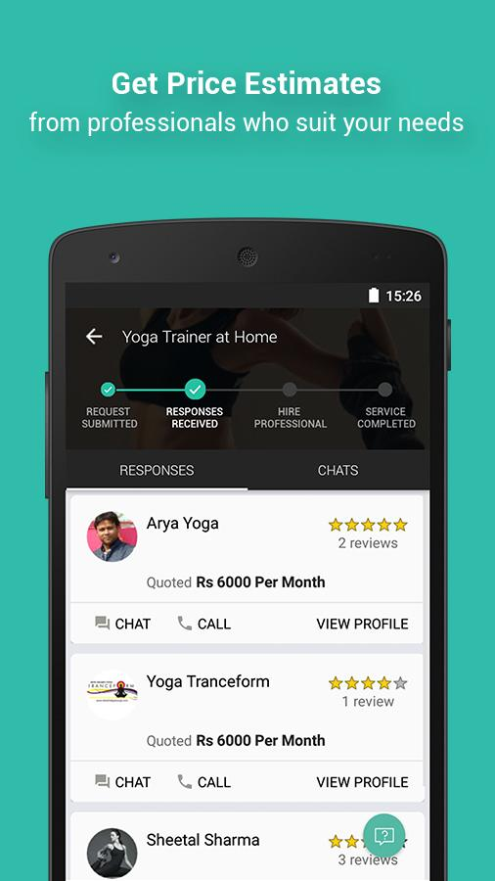

This application has slight variations in design but the features are same.

1. **Bookmyshow (Movie Booking App)**

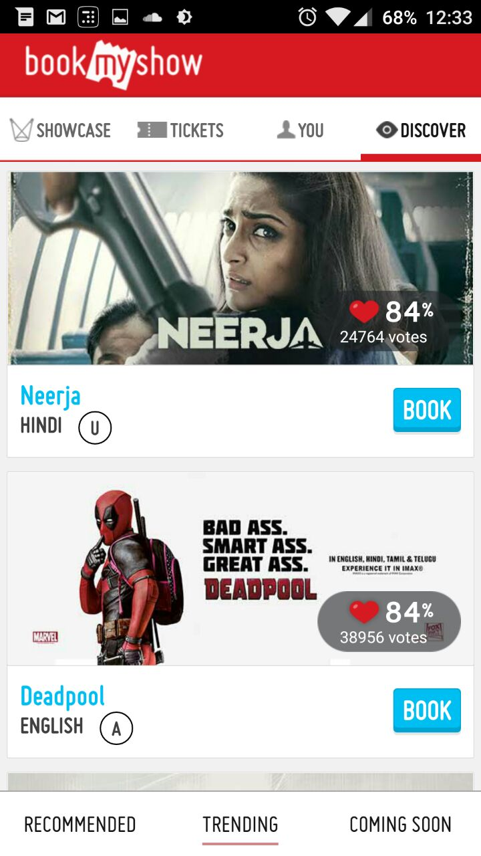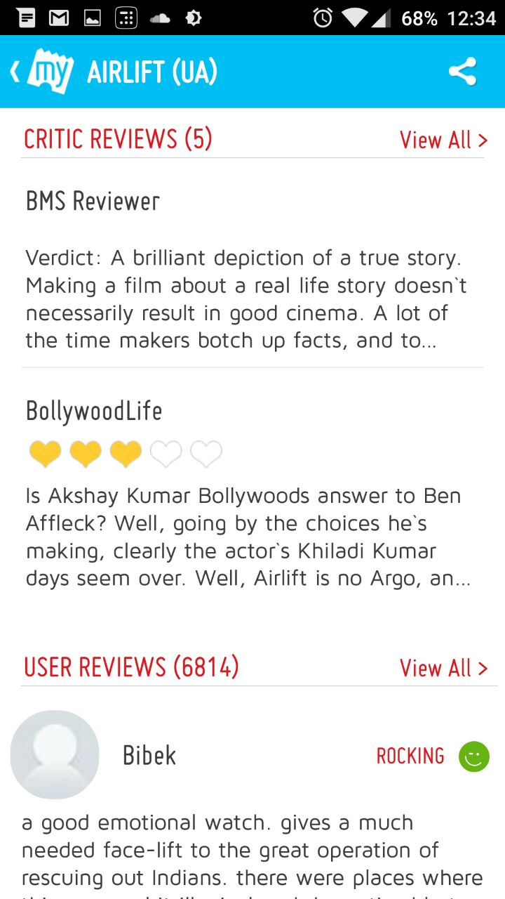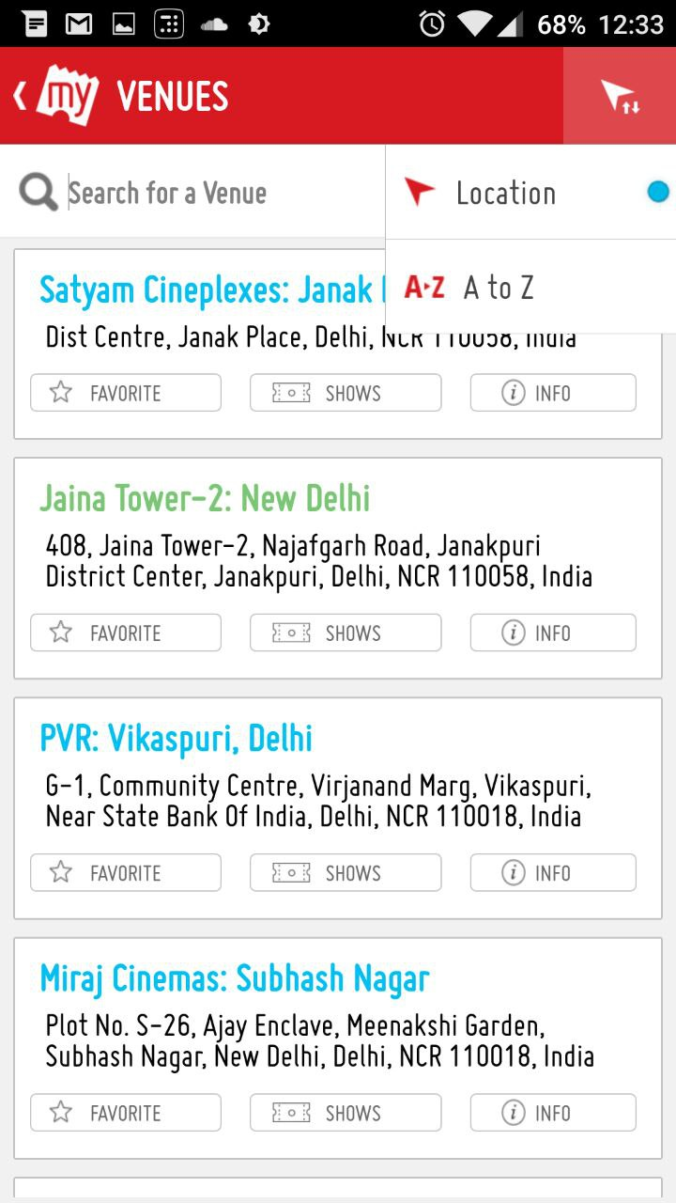

Once again, the feature set is very similar even though the entity is way too different.

And these are just the popular applications. There are more such as :

* BookMyFunction: Wedding/Function venue finder
* Housing.com: Flat/PG finder
* CarWale: Car search engine
* PolicyBazaar: Insurance Policy search engine, etc.

Not only they have an mobile application but they also have a website. So as a project manager, he/she has to first get an Android Developer, an iOS Developer, a Website Developer and a Backend Server developer before he/she can even start with the development of project.

**CONCLUSION**

* As you can see from the previous examples, they all share majority of the characteristics like the follows:
  + A home feed where user can look at trending entities
  + Sort and search entities based on popularity and attributes of the entity itself.
  + Read and give reviews & comments around the entity.
  + Contact the entity via email/phone/map directions and other mediums.
* So basically, these apps only differ in the entity they allow searching around and share the same functionality and even aesthetics around the other features like reviewing, searching, contacting.

Thankfully, the due to the presence of a common pattern, we can create a generator that caters the need of the Project Manager, without the need of any developer and just get started with the idea. We plan to automate the process of development using a modular and [component oriented programming approach](http://link.springer.com/chapter/10.1007/3-540-46589-8_10).

**INTRODUCTION**

Based on our mini case study, we can observe a pattern in these apps and we plan to develop a generator that could automate the task of developing these applications and provide a Minimum Viable Product (MVP) to the end user that he/she could use to perform instant prototyping, pitch the idea to investors, and finally build the production code on top of the generated app.

We first explain the benefits, research, principles and architecture of the project.

Following that, we lay down certain principles we follow while creating this generator to ensure that we never hard-code anything and allow end-user to customize anything at any level.

Then, the phases and stages of development will be discussed. We follow these to remain productive throughout the development cycle.

Finally, the current status of the project will be discussed.

**ADVANTAGES**

* The generator cuts down the development process to merely seconds. The end-user will supply an options file describing the entity and other aspects of the project, and the generator would work its way out to compile entire service including Server, Database Configuration, Website & Mobile Applications. The more modular the generator is, the more customization options can be provided.
* A person with an idea but lack of computer engineering skills can use the utility to immediately to analyze his/her idea directly looking at the prototype.
* Modular approach of the generator allows contributors to supply plugins that can extend the functionality, without changing the core generator. This allows the generator to remain future proof.

**ARCHITECTURE**

Now we discuss how an application like this works and what architecture is generally used.

**Website**: First the assets like HTML files CSS and JavaScript files are fetched via HTTP request.

These then communicate with the Server API using REST to get details about entity, or perform tasks like create a review, rate an entity etc.

**Application:** Unlike websites, their assets are in the application binary that can be downloaded from App Store. Thereafter, same REST protocol is used to fetch and push data to the server.

**Server:** Apart from serving static files to website and application (images etc), it also holds APIs that act as a middleware between database and application.

**ORM:** This is a part of the API that is designed to communicate with database in a much modular fashion.

**Database:** This is the central location where all the data is stored.

**DATABASE ERM**

**Attributes are missing from the ERM as they would be provided by the end-user in form of options. However some common ones like name, email, password etc would be present irrespective of user options.**



**API**

Once the Schema is created, an Object Relation Mapper (ORM) can be used to perform CRUD (create retrieve update and delete) operations on the entities. The APIs will depend on the options, however there is a general pattern in them too. For example we can implement following API routes irrespective of the options chosen by the end-user:

GET entity/:entityID POST comment/:entityID POST like/:commentID PUT user_profile/:userID

1. CRUD on User
2. CRUD on Comments/Reviews/Ratings/Likes and other user activity.
3. CRUD on Entity will need to respect the chosen attributes by the user. Here we will have to employ proper code generation techniques.

Once the API is created, the Application and Website will have to consume it too. This is where we would require proper generation techniques.

Since end-user can have different specifications for choice of database and the attributes of the entity, we will have to rely on an ORM that can abstract out details of the entity and allow us to cater all the need.

The way we plan to implement this is to have a layered modular approach as follows:

Client

Server

* If say a customer wants to use Postgresql instead of MySQL, we can rely on libraries like knex that support both of them. Catering this need would simply require change in ORM module while API uses knex’s API to query database.
* Now say if a customer wants an altogether different database, for example MongoDB. In this case, we will have to rely on ORM that supports MongoDB, like Mongoose. Since the API of Mongoose is very different than knex, both ORM and API modules will have to be updated.
* Similarly, the more choice and customization we provide, more modules will have to be updated. However, we can plug them from any source, or the end-user can write their own to leverage our generator’s other features, which becomes way better than to build everything from scratch for the end-user.

**TECHNOLOGIES USED**

1. We rely on a JavaScript library called ReactJS that uses components to create user interfaces. This helps in developing following modular approach. Further, same components can be used both by mobile application (react-native library is used for the same) and the website, which helps in more code re-usage.
2. Since the components can be simply replaced by any other component that performs the same function but with different layout/style/approach, we can allow user to choose from a variety of component replacements and truly customize entire application, layout by layout.
3. The component approach also allows contributors to write pluggable components that can extend the functionality of the app. This might require minor code changes (5-10 lines of code), but acts as highly powerful feature.
4. For the generator we will use NodeJS for it is supported cross platforms and has low learning curve but at the same time required level of control over low level APIs.
5. Each component in ReactJS has following attributes:

* State – The state is a data structure that holds the present state variables of the component. For eg a button is disabled or enabled etc.
* Properties – These are the parameters passed by an upper component.
* Render – A function that is called whenever state changes. It has the data as to how to implement the view of the component.

**PRINCIPLES FOLLOWED**

We are following principles while creating the generator:

* We follow Component Driven Development which allows us to replace functionality with minimum code change. For example, if server is implemented in NodeJS, then it shouldn’t be difficult to create a Python server as a drop-in replacement as a component. Or say if Postgresql is used for database, then it shouldn’t be hard to write a layer that could instead communicate with MySQL. The reduced dependencies and a common protocol for communication between components allows to create highly modular generator.
* We rely more on static replacement of modules than dynamic replacement. What we mean by static replacement is that, if end-user needs certain feature, instead of making changes in code, we would want to use a different module altogether. The latter is much more scalable than making changes in the code.

**PHASES OF DEVELOPMENT**

The development process is split in two phases with several stages in them.

1. App: Develop a skeleton app that can serve the purpose for a generic application. Once it is developed, generator can use code from it and provide it to the end-user with minor changes based on options provided by end-user.
2. Generator: This phase will parse the options and make necessary changes to the App created in Phase 1 (if any) to meet the needs of the end-user. For each use-case, we will create extra components and slowly support a wide variety of features in a modular way.

**PHASE 1 (APP): STAGES**

1. Use a configuration file that has metadata like name of application, name of entity etc. This file will allow generator to simply update the configuration file and modify entire application.
2. Develop a static server that provides dummy data for the website.
3. Create website using React Components.
4. Create iOS and Android apps using React-Native. Reuse as many components as we can from stage 2.
5. Create authentication system (both with and without sessions) and a real database.
6. Create different visual styles and templates for customization options until we can create apps that were mentioned in case study.

**PHASE 2 (GENERATOR): STAGES**

1. Create a basic generator that simply takes the options and performs static transformations like name of application, name of entity, theme choices, component replacements.
2. Create an engine to generate schema migrations using knex based on the given options.
3. Use above schema to transform CRUD APIs.
4. Modify user interface components to consume above APIs.
5. Add new modules that can implement a given feature until we can create apps that were mentioned in case study.

**CURRENT STATUS**

* After learning the technologies like NodeJS, ReactJS, ReactNative in the month of January, we started with the development in late January.
* So far we have achieved ~40% of the goals of the phase 1, i.e. nearly completed stage 1-3 out of 6 of phase 1.
* Side by side, work on generator has been started and right now we are working on the stage 1 of phase 2.
* We are using GitHub for version controlling and working together remotely.



* Seeing the progress, we believe that by end of March we will have a basic generator ready that can mimic Zomato in functionality and partially in aesthetics.